SOFTWARE DOCUMENT

Project: ECSE 211 Search & Retrieval Robot
Task: Software design

Document Version Number: 2.0
Date: March 10, 2020
Author: William Bouchard
Edit History:
Date | Version | Author(s) | Changes
Feb 25 | 1.0 | William Bouchard | Initial draft
Feb 25 | 1.1 | William Bouchard  Andy Li | Reworked the figures, added information on odometer
Mar 10 | 2.0 | William Bouchard | Reworked the Class diagram
1.0 TABLE OF CONTENTS
2.0 – FLOWCHART 3
3.0 – CLASS DIAGRAM 4
4.0 – ODOMETER 5
5.0 – ULTRASONIC LOCALIZATION 5
6.0 – LIGHT LOCALIZATION 6
7.0 – NAVIGATION 6
8.0 – HOOK 7
9.0 – THREAD ORGANIZATION 8
10.0 – RELEASES 9

2.0 – FLOWCHART
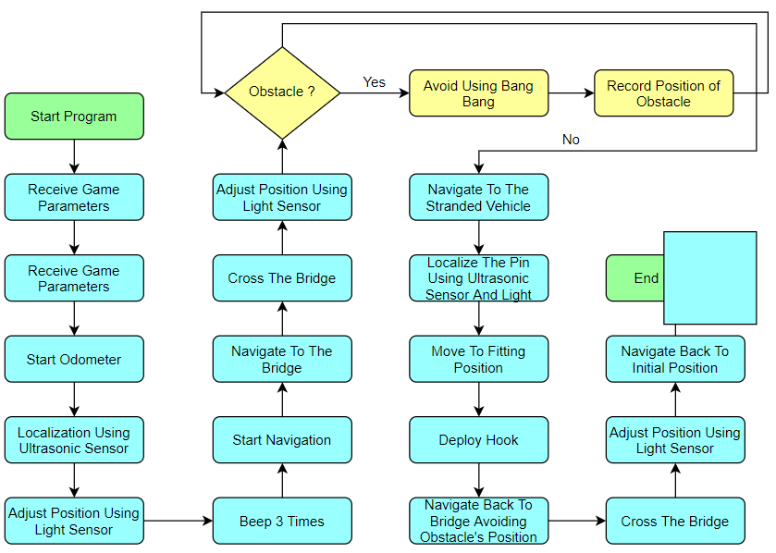
Figure 1. Software Flow

Note that the obstacle avoidance is still to be discussed amongst the team members. We will decide if we use Bang-bang or P-type correction, as each has significant advantages and drawbacks.

3.0 – CLASS DIAGRAM

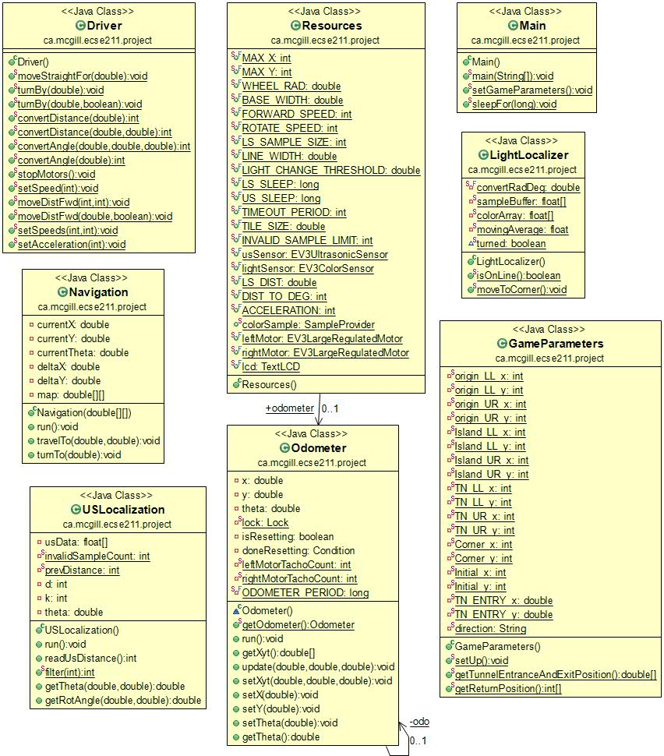
Figure 2. Class Diagram
This is a tentative class diagram for the final project. After discussion about obstacle avoidance, a class might be added to take care of this.

4.0 – ODOMETER
The odometer that we will use is the one that has been developed in Lab 2. The code should not be modified since we will be using Andy and William’s version of the odometer, which proved to be very accurate.
The actual functioning of the odometer is very simple. The odometer class measures the distance that each motor has traveled in terms of degrees rotated. It is then divided to find the number of wheel rotations and multiplied by the circumference (pi times the wheel diameter) to find the linear distance each motor has traveled.
The odometer cannot use this value directly, however, as it must break the distance traveled into x and y components. Instead, it takes the derivative of each motor’s distance traveled by subtracting the reading from the previous reading. It then finds the degree the robot has turned by calculating the difference in distance between the two motors and taking the arctangent of the difference and the wheelbase of the robot. Finally, it finds the x and y components of the distance traveled by using the sine and cosine functions and integrates the result by adding it to a running total.
A software flow will be more detailed once we make the decision of the hardware, since some changes might be needed.

5.0 – ULTRASONIC LOCALIZATION
The Ultrasonic localization to be used is the one that was developed in lab 3 and used throughout the rest of the weekly labs. The code should not be modified since it Yazdan et Ben’s version of the localization was used in lab 5 and yielded results that are pretty accurate.
From a software point of view, both rising edge and falling edge methods were implemented however we chose to use the falling edge method after finding it more consistent than the rising edge method. The falling edge method used will start rotating the robot counterclockwise until it doesn’t see a wall. Once this is done, it will keep rotating until it detects a falling edge (The distance of the robot from the wall falls below a defined distance d and a noise factor k). Once the first falling edge is detected the robot records an angle (the angle from the back wall). Recording the angle is done by calling a getter method in the odometer class. After finding the angle, the robot will change the rotating direction and turns until it detects another falling edge. It will record the angle then both angles are used to find the angle the robot needs to rotate to perpendicularly face the left wall (Y-axis). Then the robot will record the distance it had from the left wall (Y-axis) and turn another 90 degrees to record the distance to the back wall (X-axis). These recorded distances as well of knowing the dimension of the tiles would then be used to navigate to the point (1,1). Finding the constants d and k was done through trial and error. To make this process easier we made the robot ‘beep’ whenever it detected a falling edge.
A software flowchart will be more detailed once we decide on the hardware design to be used, as the placement of the sensors and motors affects how the software should be written.

6.0 – LIGHT LOCALIZATION
The Light localization to be used is the one that was developed in lab 4 and used in lab 5. We will be using Trevor and Yanis’ version since we used it in lab 5 to correct the position of the robot after the ultrasonic localization and it yielded very accurate results.
The functioning is the one that was described in the slides. So, the robot does a complete rotation and records the angles at which it detects a line. It then gets the angle difference for line 1 and 3 and the same for line 2 and 4. Using those, it makes the calculations to get the x offset and the y offset. It then corrects the x position, turns 90 degrees and corrects the y position, then it corrects the angle.
A software flow will be more detailed once we make the decision of the hardware, since some changes might be needed.

7.0 – NAVIGATION
The navigation to be used is the one developed in Lab 4 and used in Lab 5. We will be using Andy and William’s version since it allows for accurate minimum angle and gives a very efficient way to detect when the robot has reached a waypoint.
The navigation is relatively straightforward. It starts by computing the angle at which the next waypoint is located. Indeed, using the odometer’s current position and the position of the next point, the angle is computed and the robot rotates until it faces the next waypoint.
The robot turns using a minimal angle (never more than 180 degrees) by calculating the relative headings of the initial and target angle. If they vary by 180 degrees or more, the robot will generally turn left; otherwise, it will turn right. This is more complicated if the zero degree axis is between the two angles, as the degree measurement rolls over from 360 to 0 degrees. This can be addressed by adding 360 degrees to the initial angle.
After that, the robot starts a while loop to move forward. Every iteration, one thing is checked to see if the destination has been reached yet. In fact, if the current distance from the waypoint is greater than the last distance, we can safely assume that the robot reached the point and we can exit the loop. Otherwise, it keeps going forward. This method was proven to be quite efficient in lab 4 and 5.
A software flow will be more detailed once we make the decision of the hardware, since some changes might be needed.

8.0 – HOOK
The software for the hook is still to be discussed. It will depend on the hardware version that we choose.

9.0 – THREAD ORGANIZATION

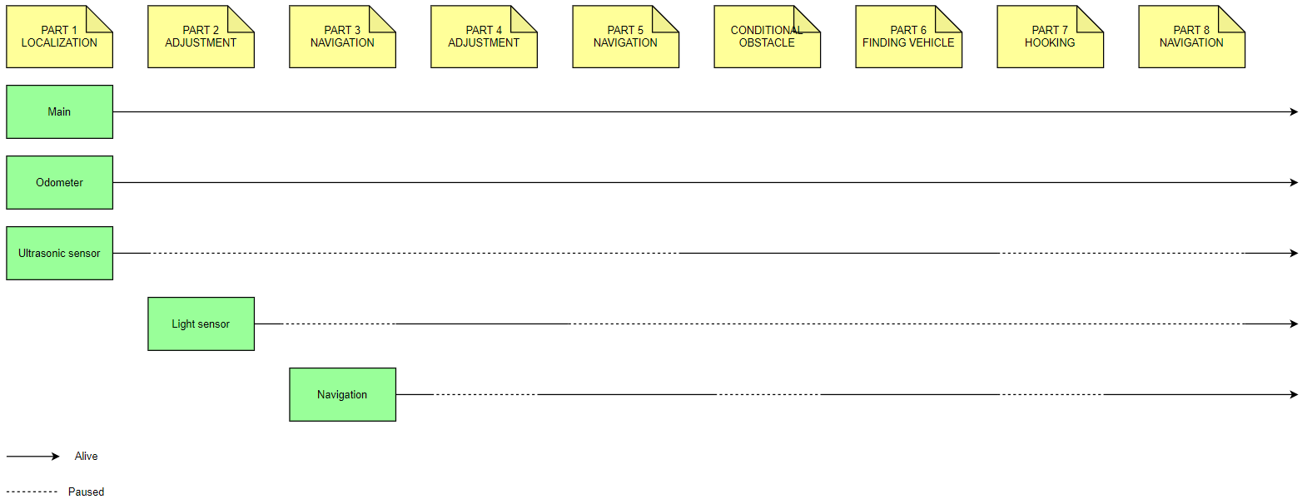
Figure 3. Tread Organization Chart

10.0 – RELEASES
Release version: 1.0
Date: March 3, 2020
Link: https://github.com/willbouch/DPMProject/releases/tag/1.0
Description:
- Implemented basic class hierarchy
- Implemented the main controlling every other thing
- Implemented the core logic of the flowchart
- Reused code from previous labs and assembled them together

